INTRODUCTION

Overview
Design and implementation of online banking system, a case study of My Bank. The greatest innovation that has taken place in the twentieth century is in the realm of information Technology. This is currently made possible by the introduction of the digital computers which has been observed in the field of communication to be increasingly inseparable from communications. These linkages often referred to as convergence is driven by technology and amplified by business trends. Faster growth in network systems that use communication links to connect subsidiary system (nodes) which may send and receives, direct and redirect information. Talking of the internet a couple of years ago would have sound like a fairytale but today the internet is pervasive in almost every field of human Endeavour changing the fundamentals of how we conduct national as well as international businesses. Few years of its existence, the internet has shown that it can deliver the long sought after goal of electronic commerce. It is worth that companies in the developed countries world-wide have recognized the business potential of the internet and are getting connected to the network of networks in their millions.
The financial institution (Bank) is one of such organizations. Banking constitutes one of the most prominent life wire for Socio-Economic grow and development in any given nation, it supports and assists in the supply of long and short term loan, accepts both current sowing and fixed deposits, both foreign transactions, advice and facilitates transactions between client, workers, agents, firm, buyers and seller by providing payment services, not excluding the issue of undertaking risk on behalf of their clients, only to mention but a few. The internet having found its application and acceptance in the banking procession has particularly put the banking industry on an accelerating pace of development.
The technological highway (the internet) has become an enabler for Banks in achieving high level productivity and in handling volumes of transaction which would have been impossible without the use of on-line banking (E-commerce). The technology facilitates linkages with clients both through the provision of information and quality service delivery, as well as in reducing barriers to entry into payment systems retail banking. Internet banking allows clients to engage in informal transaction relationship which would have taken long distance travels or movement of documents with the attendant risk of loss.
With the online banking (internet) you can at your convenience, at home and at any time review account balances and transactions, transfer funds, receive and pay bills, down-load transaction services and contact customer services just to mention but a few. An over view of the benefits and prospects of the on-line banking suggest that for banks to be relevant to their customers in term of the services they provide in the twenty-first century and in the future, must append this services provided by E-commerce in the banking system in order to stay in competition. Now the on-line banking is the one thing bank should get up and invest in internet technology to reap bounteously the benefit accruing from internet banking. While Internet continues growing and gaining popularity among crowd, mobility represents new challenges to web designers.
Wireless access is a new challenging mission in the current Internet era, with different demand for information by using less efficient terminals and networks.

1.2 Objective
To improve in the speed, effectiveness, efficiency and convenience in business transaction.
• To design and implement a computer software to solve this problem and rendering the services.
• To provide an On-line banking database for My Bank using MySQL database.
• To interface the client and server side in a cost effective and efficient manner.
• To design an interface that could be used to input transactions details for customer, and the bank staff information, able to store them in the database for further use and investigations of any bank transactions.

PROBLEM ANALYSES

2.1 Problem Definition
In banking industries today, queuing has become the order of the day, customer’s line up for hours waiting to withdraw or deposit money. This creates a lot of problem to both customers as they waste their useful time in the banking hall. The management also wastes their time as they run around to find solution to those problems. Also it is observed that customers cannot withdraw money any time they want as banks has their working hours.
This is a big problem as needs can arise at any time and human beings will always like to have those needs solved. Also money deposited into accounts at times takes some hours to reflect in the persons account balance hence making banking operations slow and unhealthy for business growth.

2.2 Approach
In the proposed system we are concentrating the problems whatever a client faced with existing manual system. By introducing online banking management system, the client provides faster services to the customer. The transaction service, report generation services and every service is available at no delay. This project is an attempt to make the task of administrator as well as customer easier. The administrator has the right to know everything. He/she has the right to know the account details of the users and bank reports. The development of the new system contains the following activities which try to automate the entire process keeping in view of the database integration approach.
The system can provide information related to the different types of accounts that are existed within the bank. The system can provide the bank administration with information on the number of customers who are existence in the system. The system at any point of time can provide the information related to executed transactions by the customer.

ARCHITECTURE

3.1 System Architecture

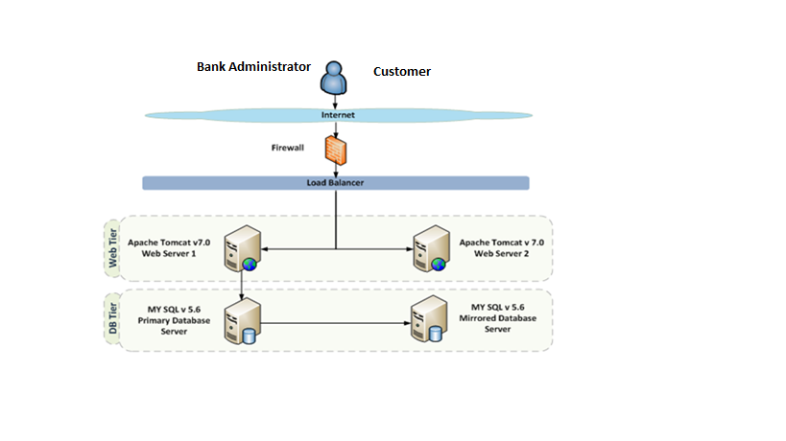
Fig:3.1

3.2 Programming Language Used
- Programming language used are HTML, JAVA script, J2EE.
- Tools Used are Eclipse, Maven.
- Database Used MySQL

3.3 Definition of Terms
- Analysis: Breaking a problem into successively manageable parts for individual study.
- Data flow: Movement of data in a system from a point of origin to specific destination indicated by a line and arrow
- Design: Process of developing the technical and operational specification of a candidate system for implements.
- Implementation: In system development-phase that focuses on user training, site preparation and file conversion for installing a candidate system
- Operation System: In database – machine based software that facilitates the availability of information or reports through the DBMS.
- Password: Identity authenticators a key that allow access to a program system a procedure.
- System: A regular or orderly arrangements of components or parts in a connected and interrelated series or whole a group of components necessary to some operation.
- System Design: Detailed concentration on the technical and other specification that will make the new system operational.
- System Testing: Testing the whole system by the user after major programs and subsystem has been tested.
- Unit testing: Testing changes made in an existing or new programs.

DESIGN

4.1 System Flow
The data flow diagram depicts the flow of the information within the system. The system and its user act as link with all the information following into them. Customer/admin act the source as all the request are generated by him. The record is held in the storage spaces depict by partially open rectangle. Arrows within the flow diagram is quit important as its records in a pictorial form all the information flow within the system. With the help of flow diagram we can identify the current information structure of the system. The structure of the system can thus be analyzed and it helps in making improvement within the current system.
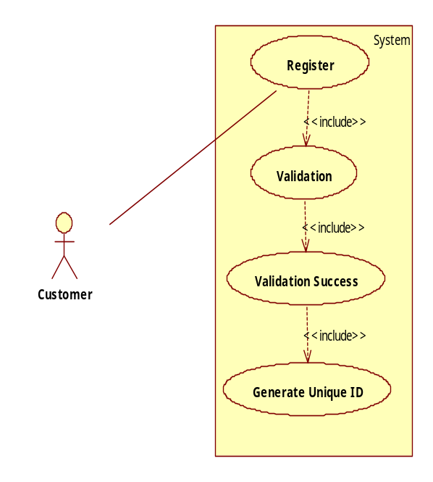
Fig: 4.1

This procedure collects all the personal information like name, date of birth, address, phone number, e-mail, verifying person, initial amount to be deposited from the user and provides unique identification number and account no. Using which user can make transaction after accepting only identification number and account number. It saves the information given by the user in our maintained database through file system support.

Implementation

5.1 Database Implementation
Our choice of MySQL database is due to the fact that it can be used to set up a query which, when applied to a database typically returns a set of records that matches your SQL (Structured Query Language) query. It is also used to handle large databases
Several database tables and forms were designed and implemented in this project using MYSQL (Structured Query Language) database. Each of these tables and forms has their corresponding user interface that enables the user to supply data to the system. Application table was designed for this system in order to capture the account number of each application submitted. Once an application is entered, it is automatically numbered and this is seen on top of every application / Account registration form .The account number of every application is automatically captured and stored in the account database table. In the implementation phase, the project reaches fruition. A critical phase in SLDC (System Development Life Cycle) is the successful implementation of the system; implementation simply means bringing the new system into operation.

5.2. System Object Model

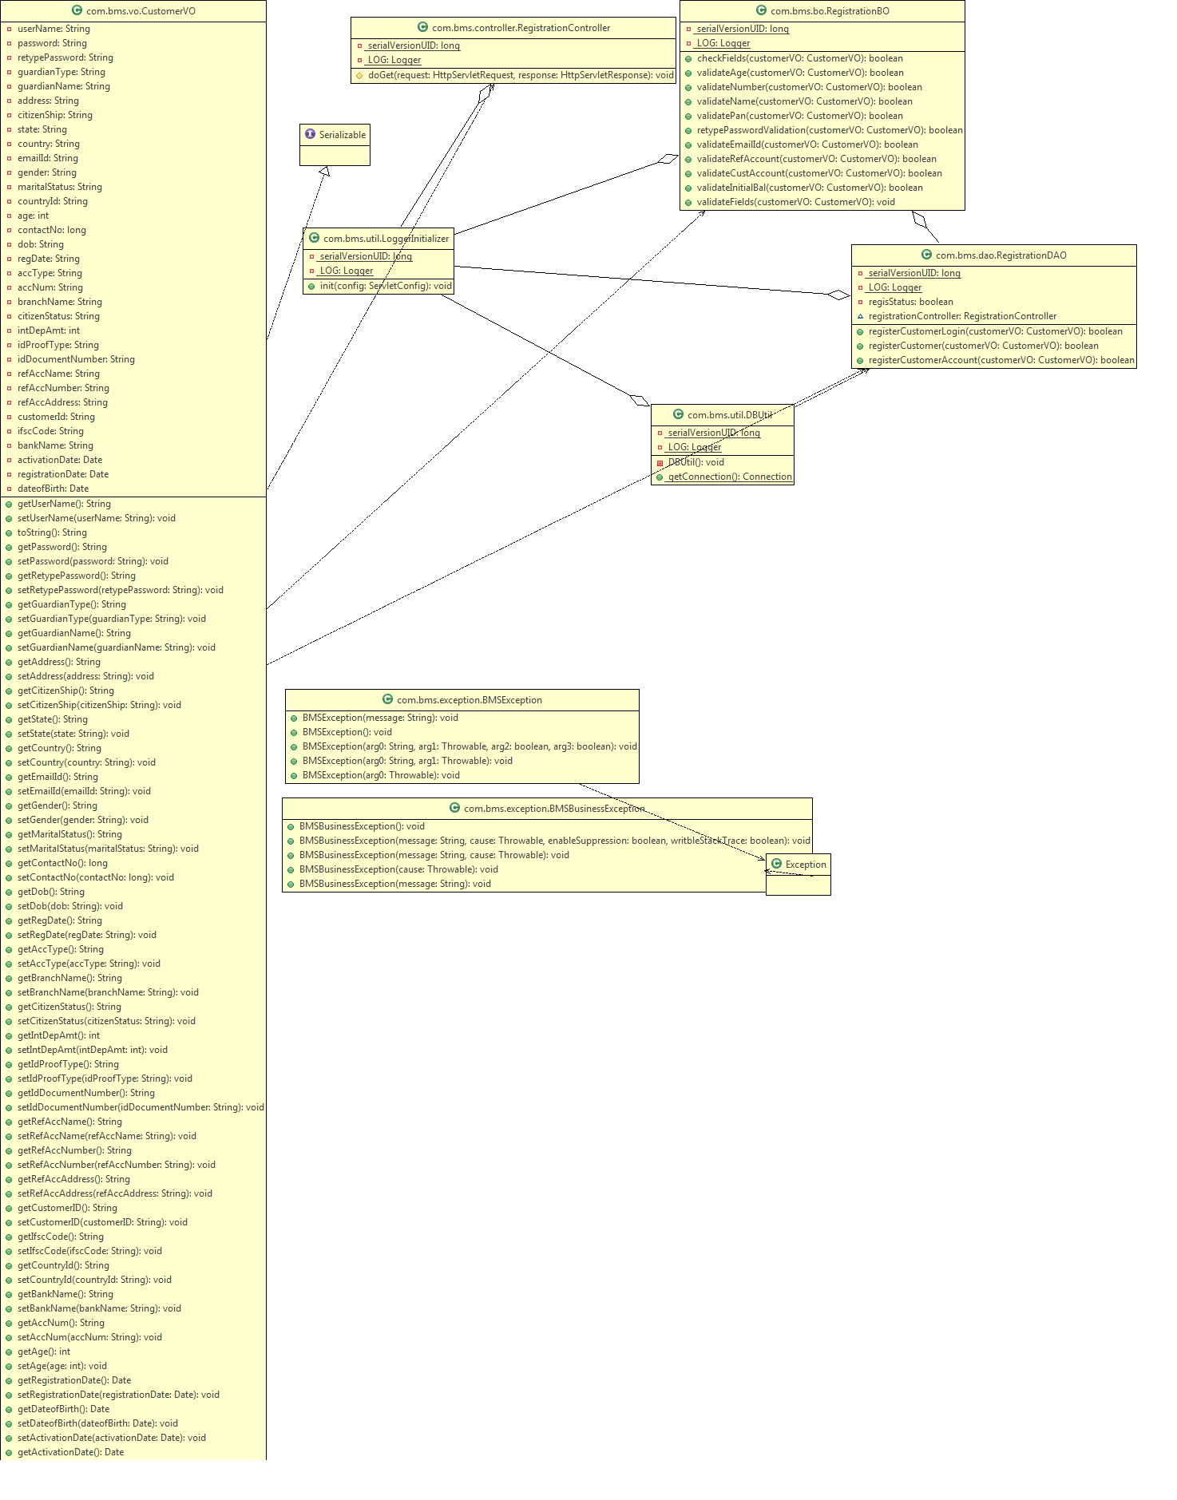
Fig: 5.2

5.3. Component Descriptions

Class | Method | Program Logic
Registration Controller | doGet()  Parameters  HttpServletRequest request, HttpServletResponse  Return Type  void | - Get the Registration details from request.  - Set the registration details in the RegistrationVo object  - If all the details are valid then  - Forward the response to the view page using a RequestDispatcher if the operation is successfully completed. Else redirect to the error page.
RegistrationBO | checkFields()  Parameters  CustomerVO customerVO  Return Type  boolean | - Validate all field and give Boolean true when all details are entered.
 | validateAge()  Parameters  CustomerVO customerVO  Return Type  boolean | - Check the minimum and maximum age of customer and return true if it is valid according to requirement.
 | validateNumber()  Parameters  CustomerVO customerVO  Return Type  bolean | - Validate the contact number entered .
 | validateName()  Parameters  CustomerVO customerVO  Return Type  boolean | - Validate the user name of the customer.
 | validatePan()  Parameters  CustomerVO customerVO  Return Type  boolean | - Validate the PAN number format.
 | retypePasswordValidation()  Parameters  CustomerVO customerVO  Return Type  Boolean | - Compare the password and retype password.
 | validateEmailId()  Parameters  CustomerVO customerVO  Return Type  Boolean | - Validate the email format.
 | validateRefAccount()  Parameters  CustomerVO customerVO  Return Type  Boolean | - Validate the reference account number. It should have 16 digits.
 | validateInitialBal()  Parameters  CustomerVO customerVO  Return Type  Boolean | - Validate the initial account balance according to requirement.
 | validateFields()  Parameters  CustomerVO customerVO  registrationDAO | - Validate and pass validated details to class RegistrationDAO
CustomerRegistrationDAO | registerCustomerLogin  Parameters  CustomerVO customerVO  Return Type  int | - Returns count value indicating successful registration of customer login details.
 | registerCustomer()  Parameters  CustomerVO customerVO  Return Type  int | - Returns count value indicating successful registration of customer personal details.
 | registerCustomerAccount  Parameters  CustomerVO customerVO  Return Type  int | - Returns count value indicating successful registration of customer account details.

Table: 5.3.1

5.4. User Interface Controls

Data Element | Control type | Default Values | Editable Field | Restrictions | Mandatory/  Non Mandatory | Data Type | Data  Size
Name | Textbox | No | Yes | Only Alphabets | Mandatory | Varchar | 30
Username | Textbox | No | Yes | Only Alphabets | Mandatory | Varchar | 30
Password | Textbox | No | Yes | Only Alphanumeric and special char | Mandatory | Varchar | -
Re-type Password | Textbox | No | Yes | Only Alphanumeric special char | Mandatory | Varchar | 50
Guardian Type | Combo box | No | Yes | Only Alphabets | Mandatory | Varchar | 30
Guardian Name | Textbox | No | Yes | Only Alphabets | Mandatory | Varchar | 30
Address | Textbox | No | Yes | Only Alphanumeric | Mandatory | Varchar
Citizenship | Combo box | No | No | Only Alphabets | Mandatory | Varchar
State | Combo box | No | No | Only Alphabets | Mandatory | Varchar
Country | Combo box | No | No | Only Alphabets | Mandatory | Varchar
Email Address | Textbox | No | Yes | Only Alphanumeric | Mandatory | Varchar | 50
Gender | Combo box | No | No | Only Alphabets | Mandatory
Marital Status | Combo box | No | Yes | Only Alphabets | Mandatory | Varchar
Contact no | Textbox | No | Yes | Only Numeric | Mandatory | Num | 10
Date of Birth | Textbox | No | Yes | Valid Date format | Mandatory | Date
Registration Date | Textbox | Yes | Yes | Valid Date format | Mandatory | Date
Account type | Combo box |  | Yes | Only Alphanumeric | Mandatory
Branch Name | Combo box | No | Yes | Only Alphabets | Mandatory | Varchar | 30
Citizen status | Textbox | No | No
Initial Deposit Amount | Textbox | No | Yes | Only Numeric | Mandatory | Num | 10
Identification Proof Type | Combo box | No | Yes |  | Mandatory
Identification Document No | Textbox | No | Yes | Only Alphanumeric | Mandatory | Varchar | 30
Reference account holder name | Textbox | No | Yes | Only Alphabets | Mandatory | Varchar | 30
Reference account holder acc. No | Textbox | No | Yes | Only Alphanumeric | Mandatory | Varchar | 30
Reference account holder address | Textbox | No | Yes | Only Alphanumeric | Mandatory | Varchar | 50
Alternate Address | Textbox | No | Yes | Only Alphanumeric | Mandatory | Varchar | 50
Alternate Contact Number | Textbox | No | Yes | Only numeric | Mandatory | Varchar | 50

Table: 5.4.1

SUMMARY

A summary of the achievements of this project, the existing system was analyzed, after which information were gathered followed by the analysis of those data. Based on the analysis, the limitations of the existing system were identified which initiated the choice of this project topic. This was followed by the system design, specification, database design, client side design, server side design, interface design and system security design. The implementation of these designed units was carried out successfully. After the design and implementation of the various units, system testing was carried out both on unit and general testing basis using test data to check the expected and actual test result. Finally, the performance evaluation of the system was certified since it is doing what it was designed to do.

REFERENCES

Fluaghter, R. (1990), Computerized Adaptive Testing, Hillsdale, New York: ACM press.
Glass, H. (2000), Interpretation of International Banking System, New Jersey: Vintage publication.
Klausmeier, J. (1984), Networking and Microcomputers Eric Digest NY, Clearing House on Information Resources, New York: Academic press.
Lewis, I. (2001), Computerization of Banking Systems, New York: Pearson Publication.
Molina, J.K. (1997), Item Banks Information Storage and Management.
Olea, J. & Prieto, G. (1999), Tests Information: Fundamental Application. Educational Research, Washington DC: DP Publication ltd.
Renom, J. (1997), Perspective Tests Adaptive Information, New York: Yarchi Press.
Sands, W. (1997), Computerized Adaptive Testing, American Psychological association, Washington DC: McGraw Hill.
Vossen, G. (1991), Data Models, Database Languages. And Database Management Systems Adison-Wesley Publishing, New Orleans: Pitman Publication.
Wise, S., & Kingsbury, G. (2000), Practical Issues in Developing and Maintaining a Computerized Adaptive Test: Fundamental Application, New York: ACM Press.

APPENDIX A
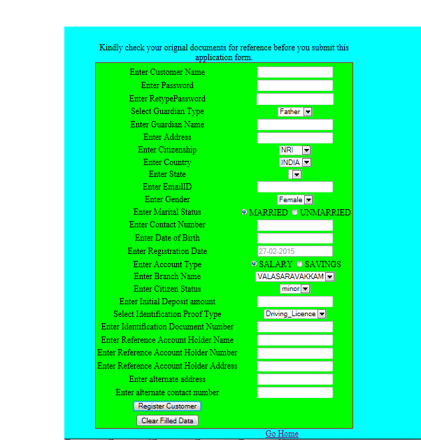

Project Review Evaluation Sheet

Components Distribution | Marks Awarded
Problem definition, motivation and objective (3)
Literature Survey or related work (3)
Preliminary design and module description (3)
References (1)
Total (Out of 10)

Signature of Internal Guide with Name

